Solidarity to the After-School Program Children
November 19,2020

In celebration to the Feast of St. Elizabeth of Hungary, November 17, 2020, we, FMSC sisters in Quezon City, are grateful to God for the opportunity to share groceries to the families of our children in the After-School Program.
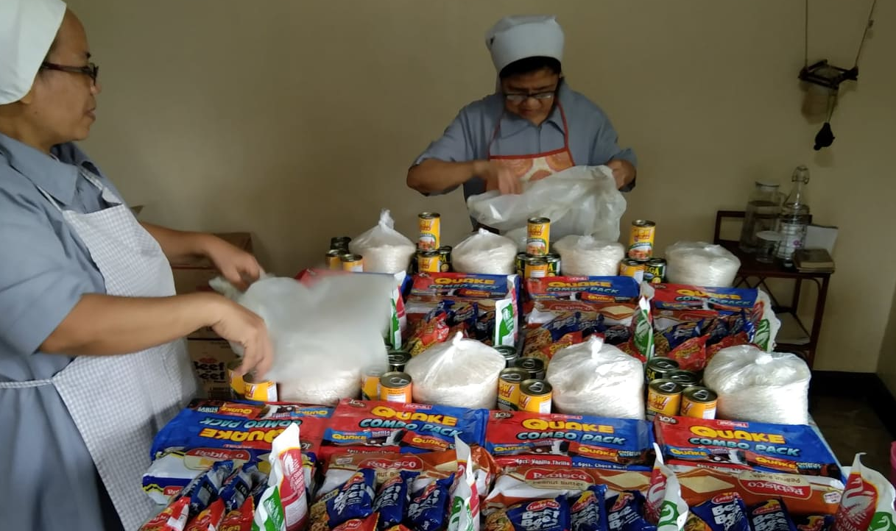

Some of our children are required by their teachers to cultivate flowering plants. They asked some from the sisters.
Our message to them:
Happy Feast Day St. Elizabeth of Hungary
November 17, 2020
(inaasahan namin na kayo ay mag-research ng isang katangian ni St. Elizabeth sa internet at paki send po sa FB ng sisters)

Ang pagpapasalamat ay tanda ng pagpapala, kaya sa bawat pagkakataon na tayo’y may natatanggap, maliit man o malaki, huwag makalimot magpasalamat.
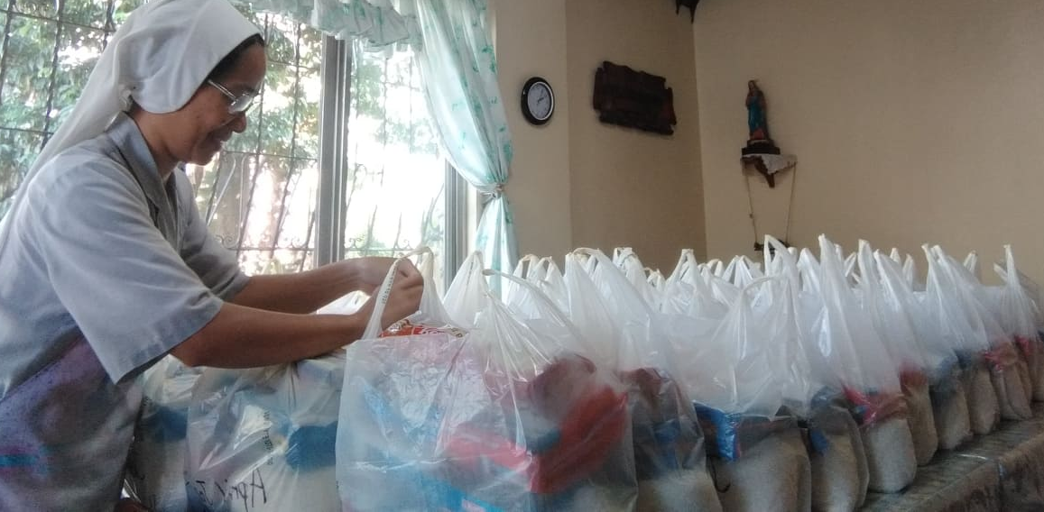

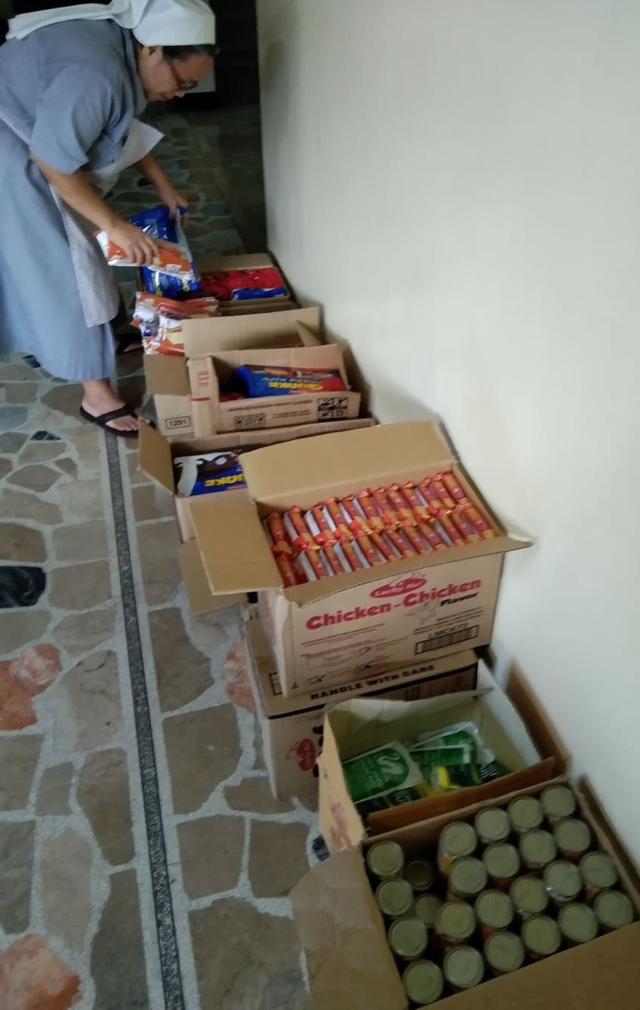

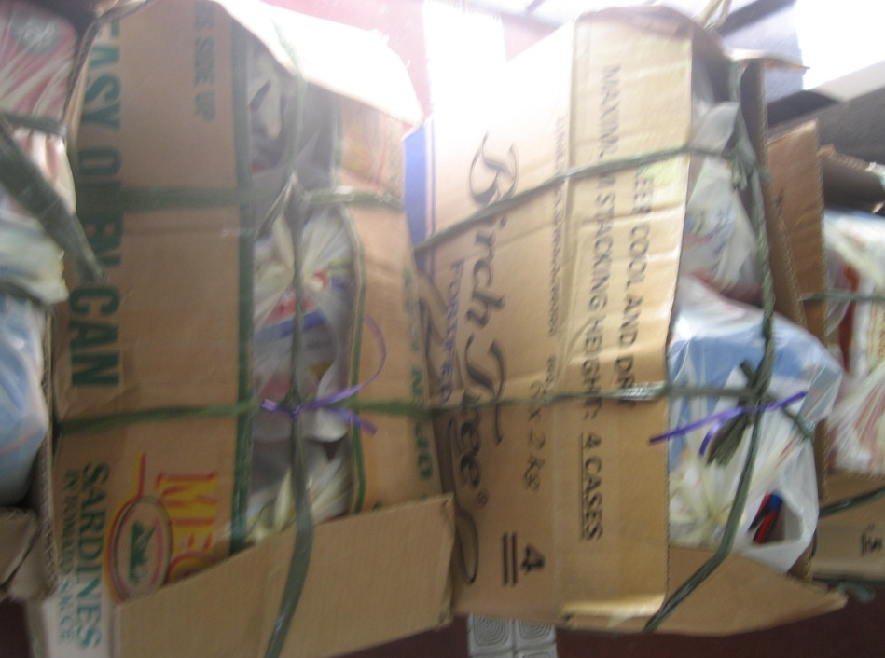

We are expressing again our heartfelt “thank you” for all our benefactors who are very concern to our children and to the needy.
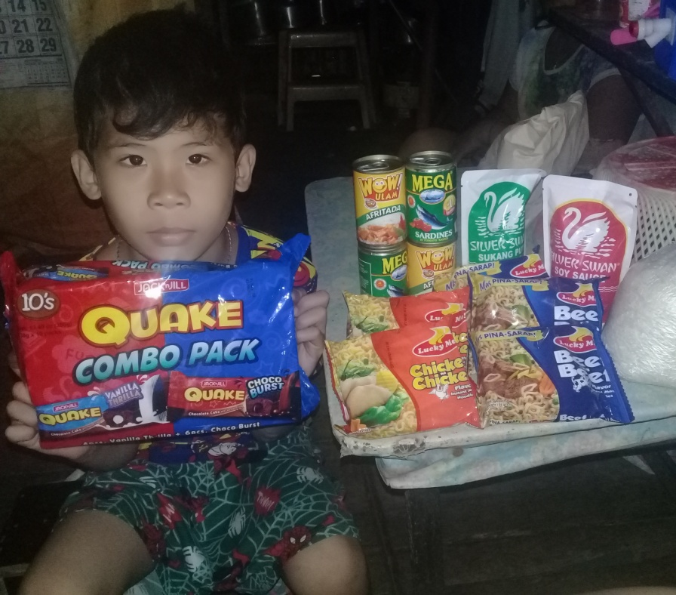
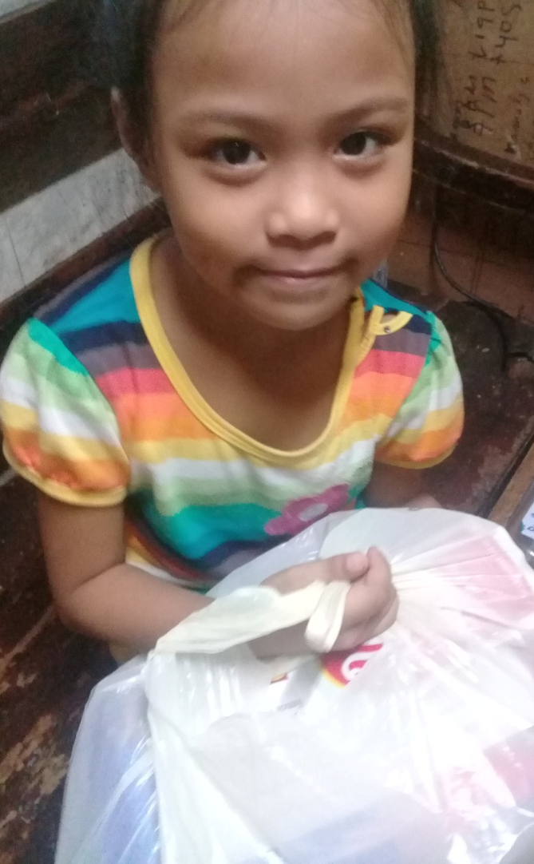

Through the intercession of St. Elizabeth of Hungary, may the Lord continue to bless all of you with good health and serenity.

