“After-school Program”- Groceries to the Families
FMSC Quezon City, Filippine
October 2020 distribution
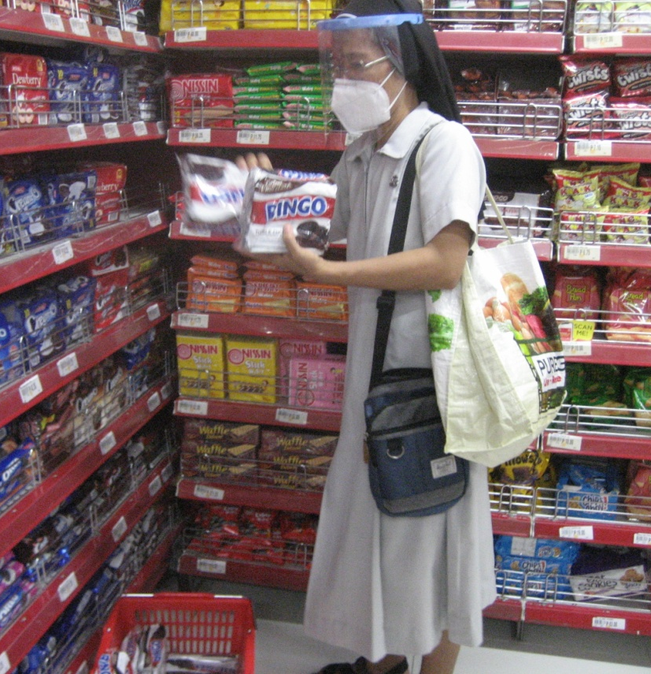
As we remember Mama Mary, in this month of Rosary (October), we have the joy again to share groceries to the families of our children in the “After-school Program”. The distribution was made on October 18, 2020. It was a very significant day, because it was also the World Mission Sunday.

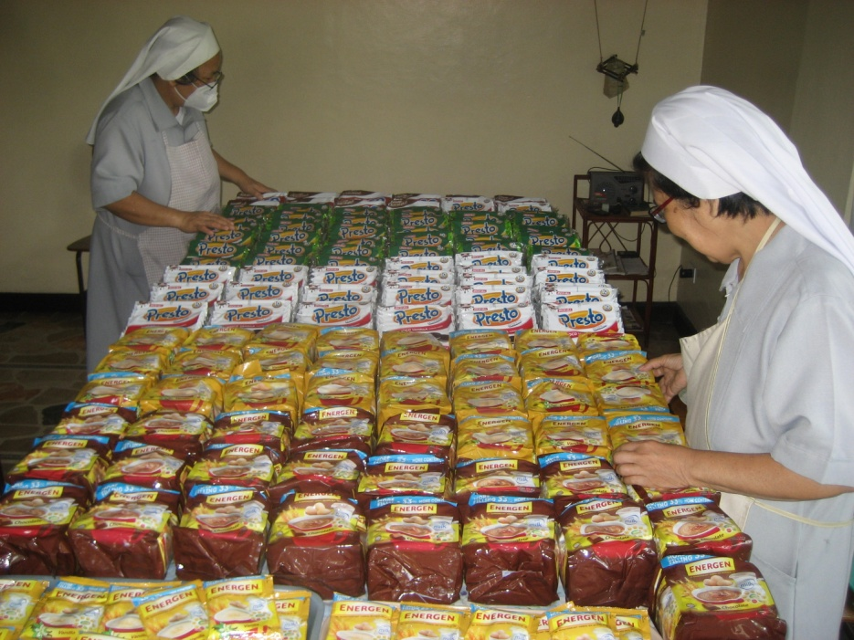

To our Dear Sabrina and members of TAU Onlus: it is through your generosity that you have concretely lived-out your contribution to the Mission of the Church towards the poor.
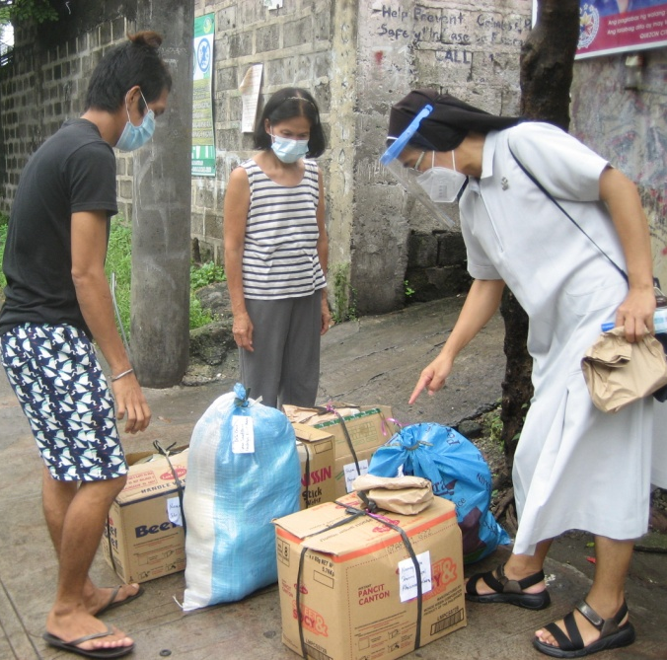
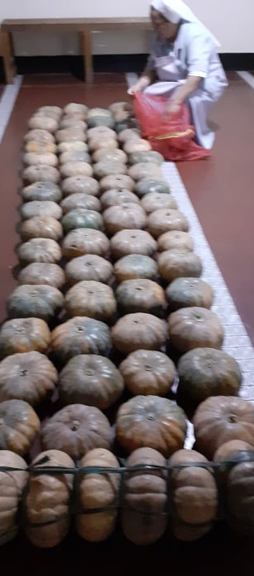

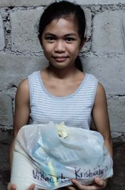
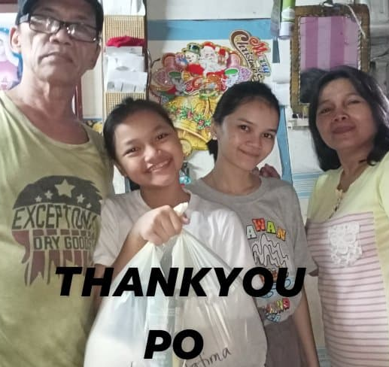
We, FMSC sisters, once again, are expressing our heartfelt “thank you”. Our children, together with their families, are very grateful, as can be seen in their pictures below.
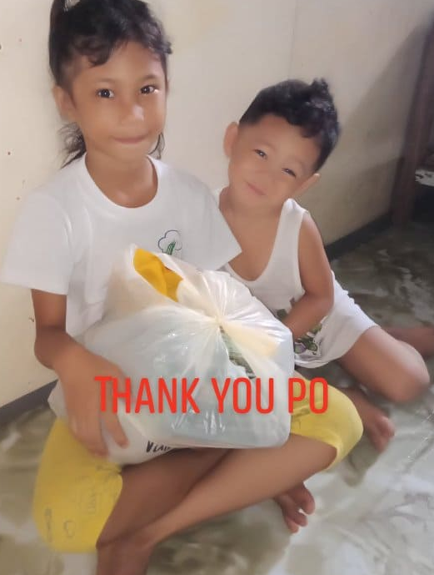
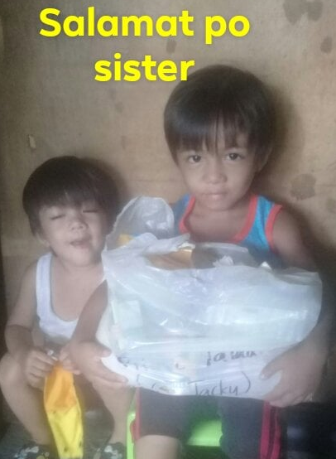

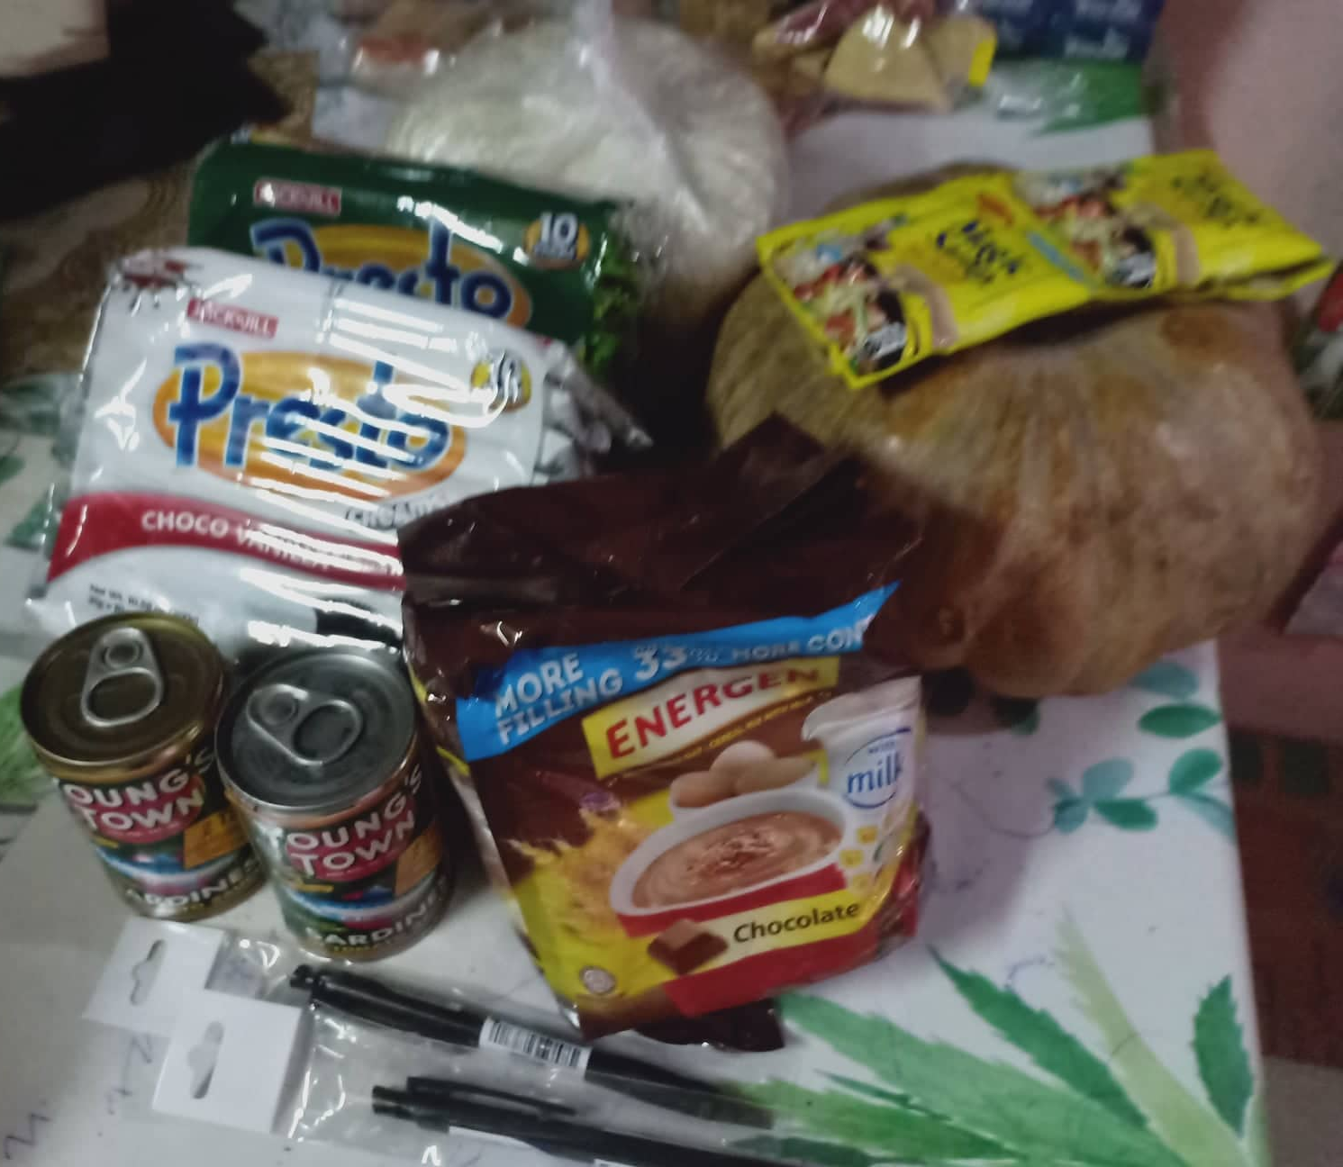
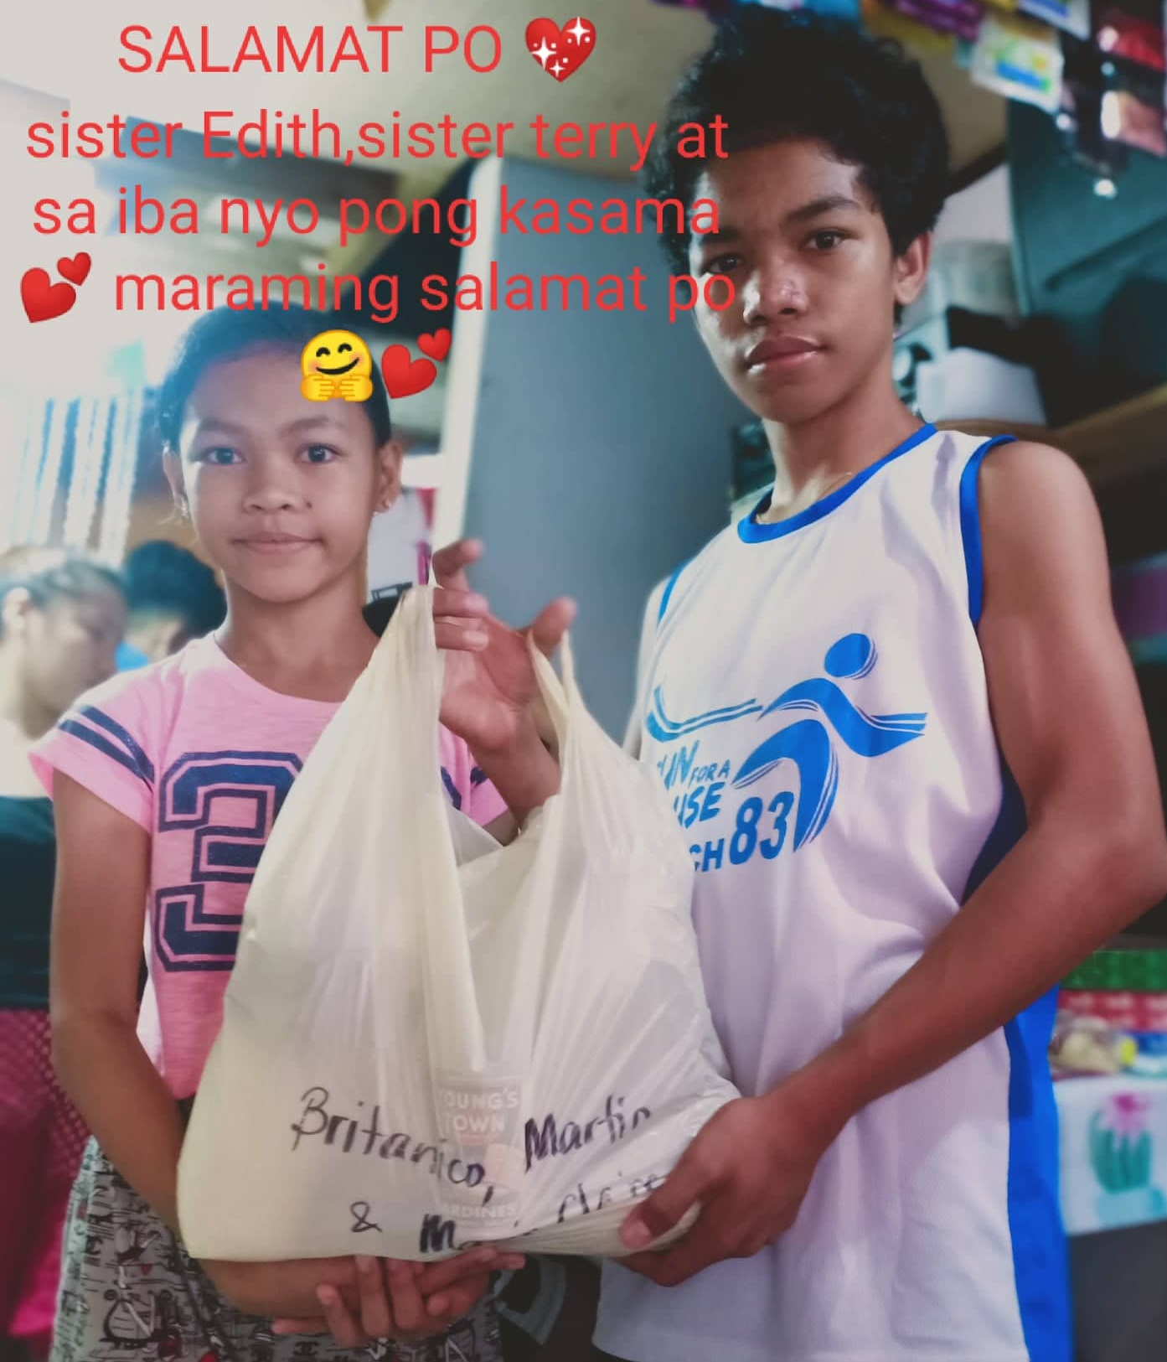
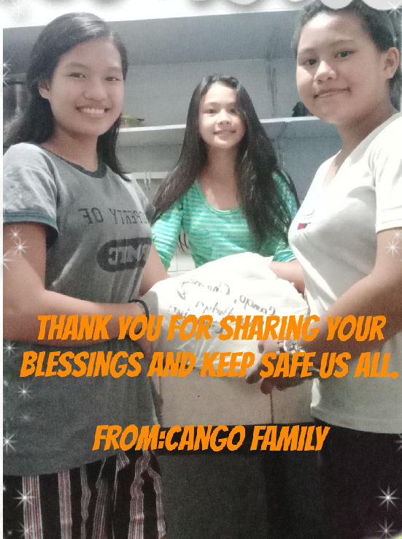

Grazie per aver condiviso le vostre benedizioni. Dio vi benedica.

