[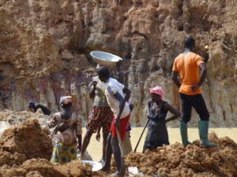](http://i2.wp.com/www.africarivista.it/wp-content/uploads/2015/11/Miniera-02.jpg)