FRANCISCAN MISSIONARY SISTERS OF THE SACRED HEART
Sitio Old Boso Boso, Brgy. San Jose, Antipolo City, Rizal, Philippines
E-mail: st.elizabeth_boso2@yahoo.com Cell. No. 09193581853/09193283209
Holy Christmas 2019
Dearest Sabrina,
First of all I would like to greet you good day! I hope that you are in good health. Thank you for the email that you had sent together with the amount of money for the Kids and for the mission. We too are doing fine with the grace of God. This time we are quite busy preparing Holy Christmas especially with the children for their Christmas Parties in different places where we used to go for apostolate.
I would like to thank you once again for the help you are extending to Rose Anne as well as for her family and for this I can say that Rose Anne is continuing her studies, even if she finds it hard and difficult at times, as she said. Lately, we talked about it and we encouraged her to be patient, to make sacrifices and strive to pursue it for the good of her future and be able to help her family.
As what I’ve told you before that she is in cooking course and sometimes she will bring for us a small piece of what they cooked or baked to let us also taste. For this I am sending to you e few of her pictures together with her group-classmates.
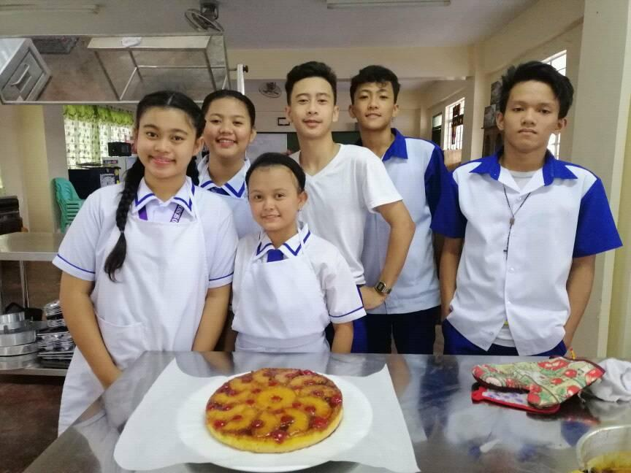
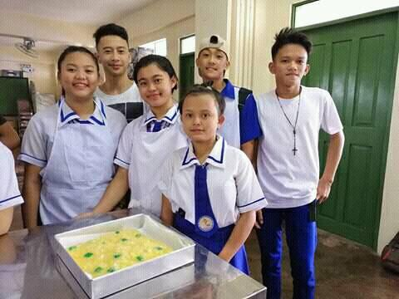
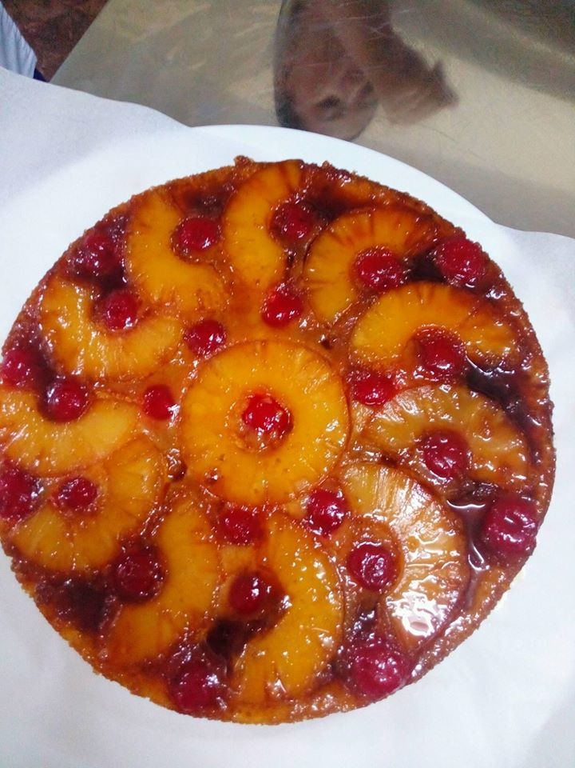

Reynold is continuing his studies, even if he finds it hard and difficult, as he said lately. We also talked to him as we encouraged hi to study and not to play at all time.
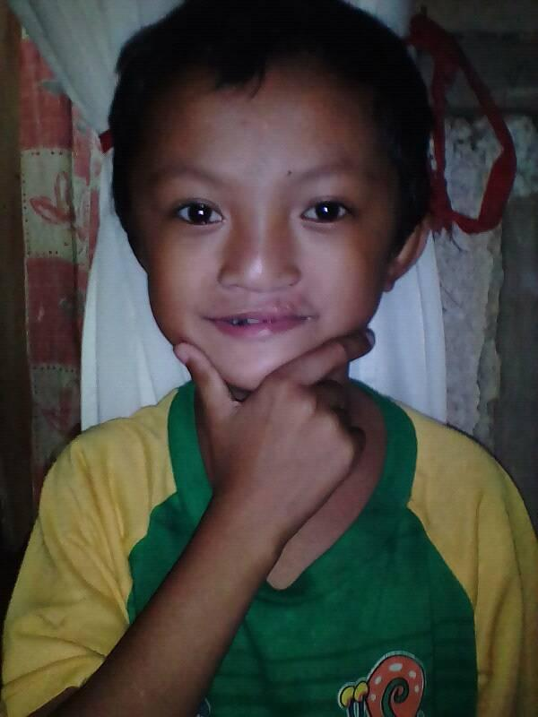
Rubencent too is doing fine in health and studies. In school he remains active especially in school activities, thanks for the help that you are extending for him, it means a lot to him and his family as well.
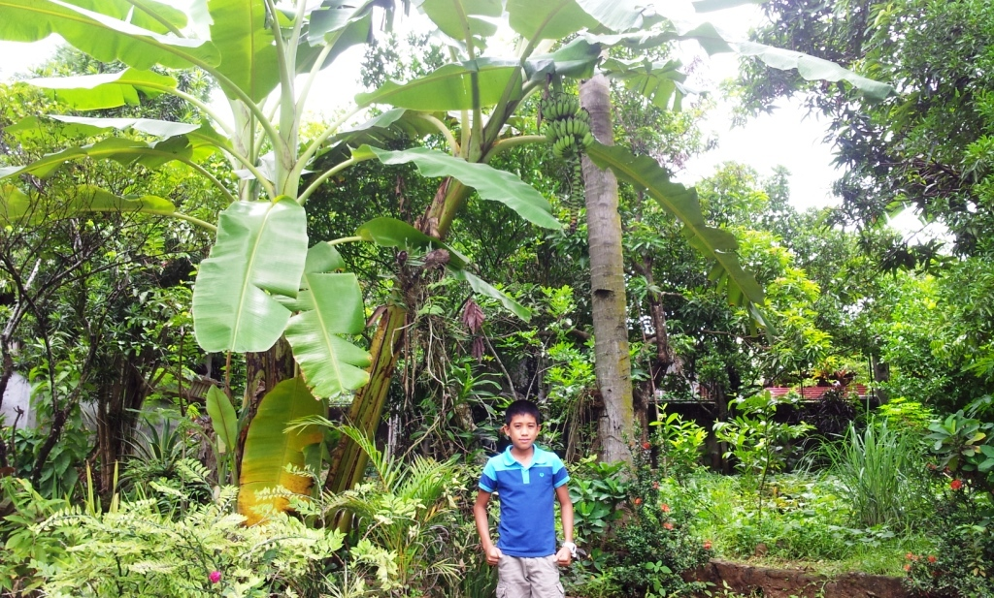
Mark James is fine, thanks God! He continues studying well and he is active in school activities as well. We also thank you for the support that you are extending to him, it helps a lot to him and his family also. Unfortunately, I don’t have any recent photo of him.
KC too is doing fine in health and in school, thanks for the help that you are extending to her, it means a lot to her and her family as well. She got good grades and she is very active in school.
Here, she is having activities in school and lately with her group they won the dance contest, that’s why she holding the trophy.

Lineth is fine, thanks God! She is studying well and she is active in school activities. We thank you for the support that you are extending to her it helps a lot to her and her family also.
These past few days they had “Search for Mr. and Miss GCM75 2019-2020”. It’s a school activity and it’s a kind of contest. Thanks God she was able to win 4 awards: Miss Photogenic, Best in Talent, 2nd Runner Up and Best in Q and A (answer and question). For this I am sending to you some of her pictures.
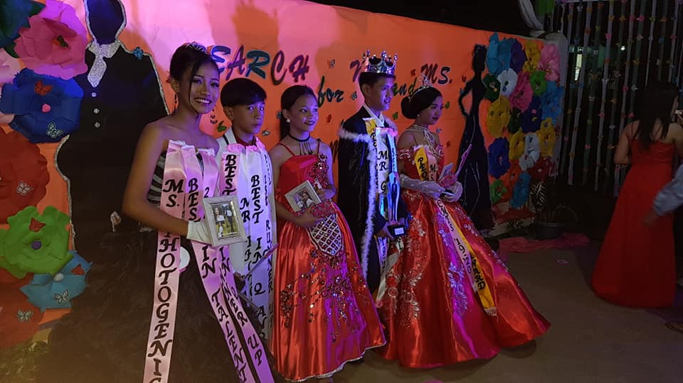
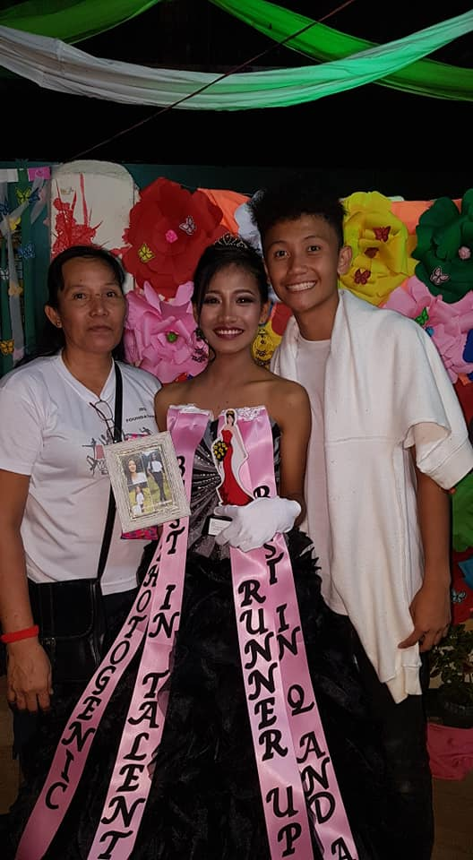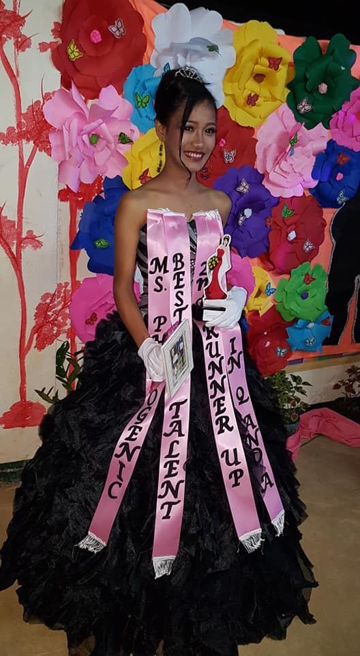
Here she is with her Mother and her brother.
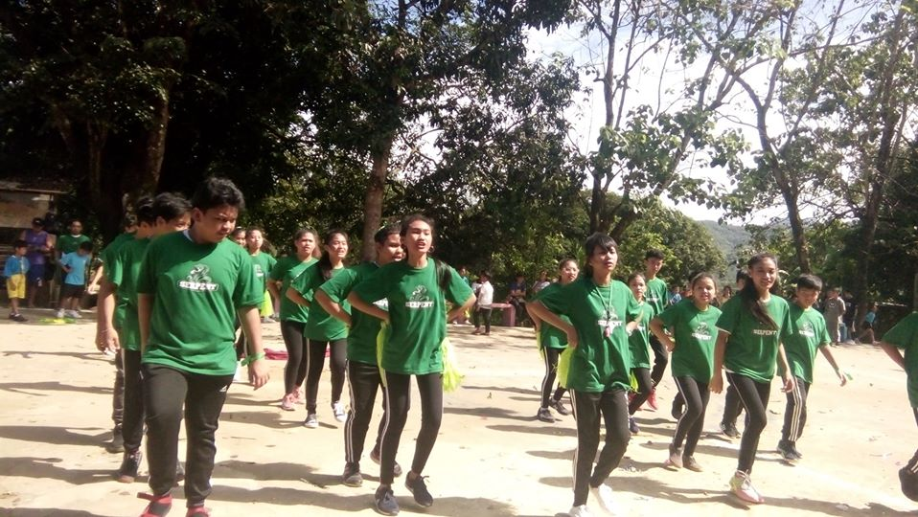
Here she is in another school activity with her group of the “cheering squad”. She is at the second to the right side.

Simple is fine, thanks God! She continues studying well and she is active in school activities. We thank you for the support that you are extending to her it lightens a lot to her and her family also.
For this I am sending to you a few of her pictures.
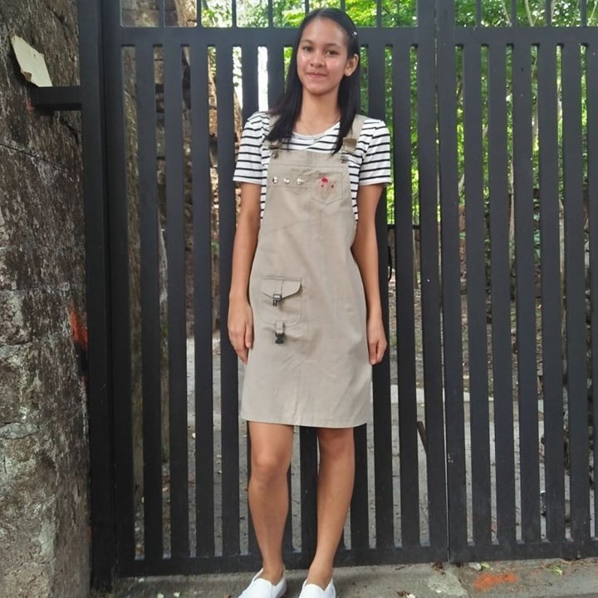
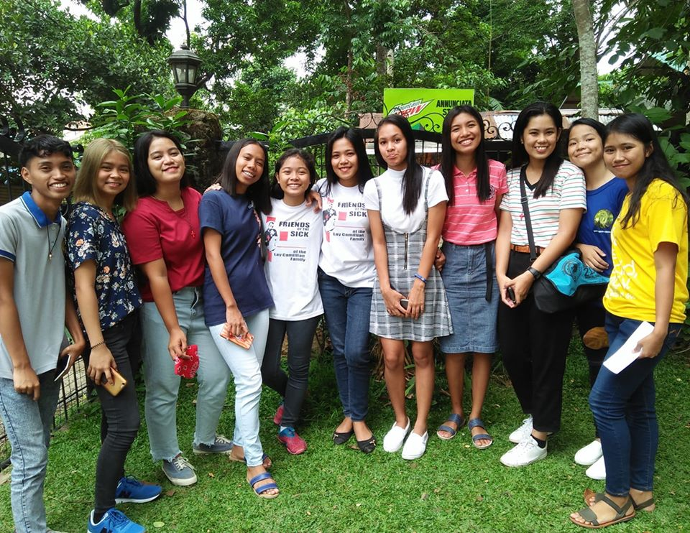
Here she is with the choir group. She is on the 5th from the right side.

Before I end, I just want to update about Sonny Rose.
Unfortunately, her father died last December 4 they found difficulty to bury him soon because they were not able to meet soon the amount payable for the funeral service. We were there one day to celebrate the Holy Mass with the Parish Priest and we gave to her an amount as contribution for the funeral expenses.
We were glad to know that she enrolled back to school. Right now she is studying in order to finish her studies. By next year, January of 2020 she will be having her “Practicum” and hopefully she will be graduating by June of 2020 as a teacher according to her. We trust in God’s mercy.
Enclosed therefore, are few photos in school with her friends and classmates.

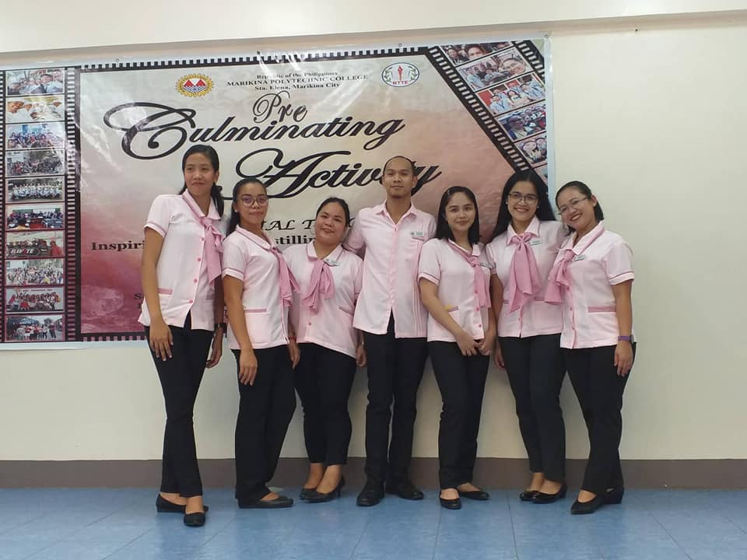
She is the tallest in this picture, the first from the left.
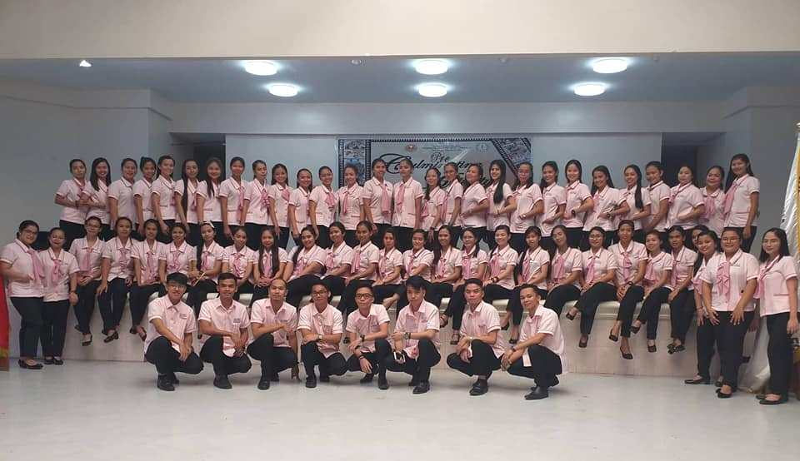
Here she is with her co graduating classmates. She is the 7th from the right side (in the middle row).

So in behalf of the Kids we are sending to you our heartfelt gratitude and greetings for the Christmas Season, the love, joy and peace of the Infant Jesus brings to us in the manger.

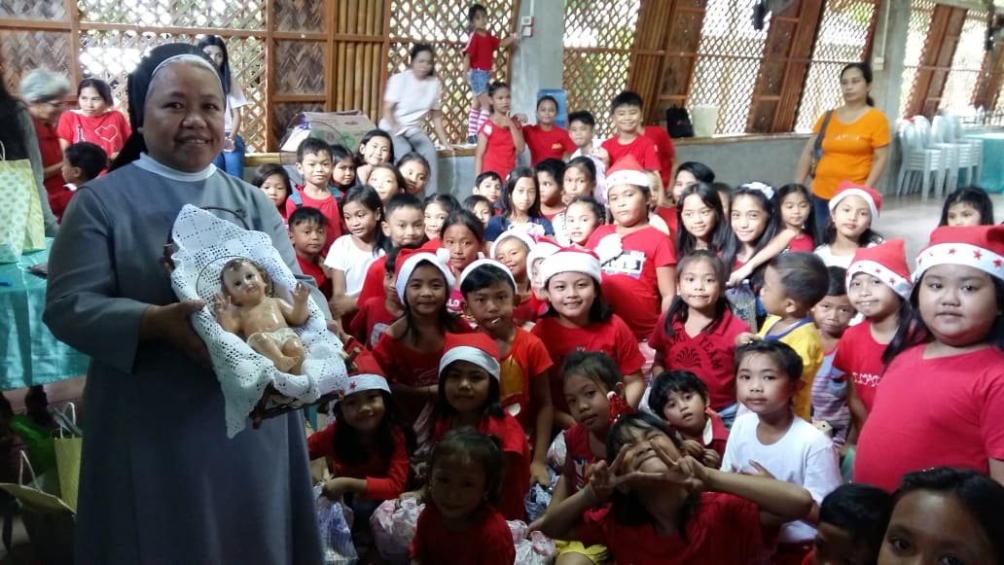

Merry Christmas and
a grace-filled
New Year 2020!

With prayerful wishes,
sr. Lucy and sr. Carlota

