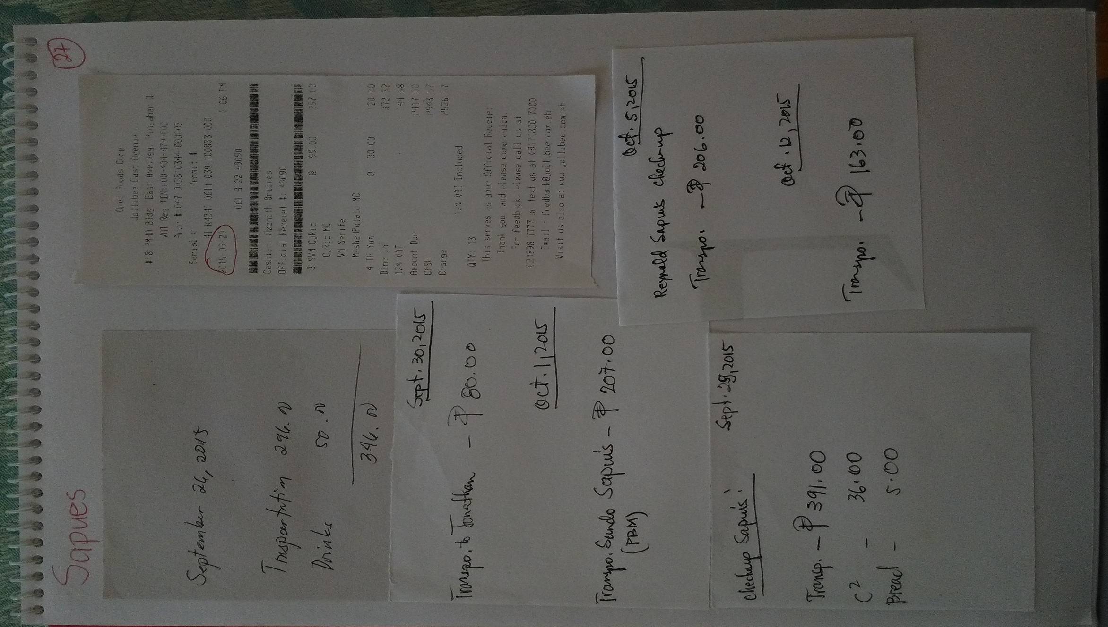

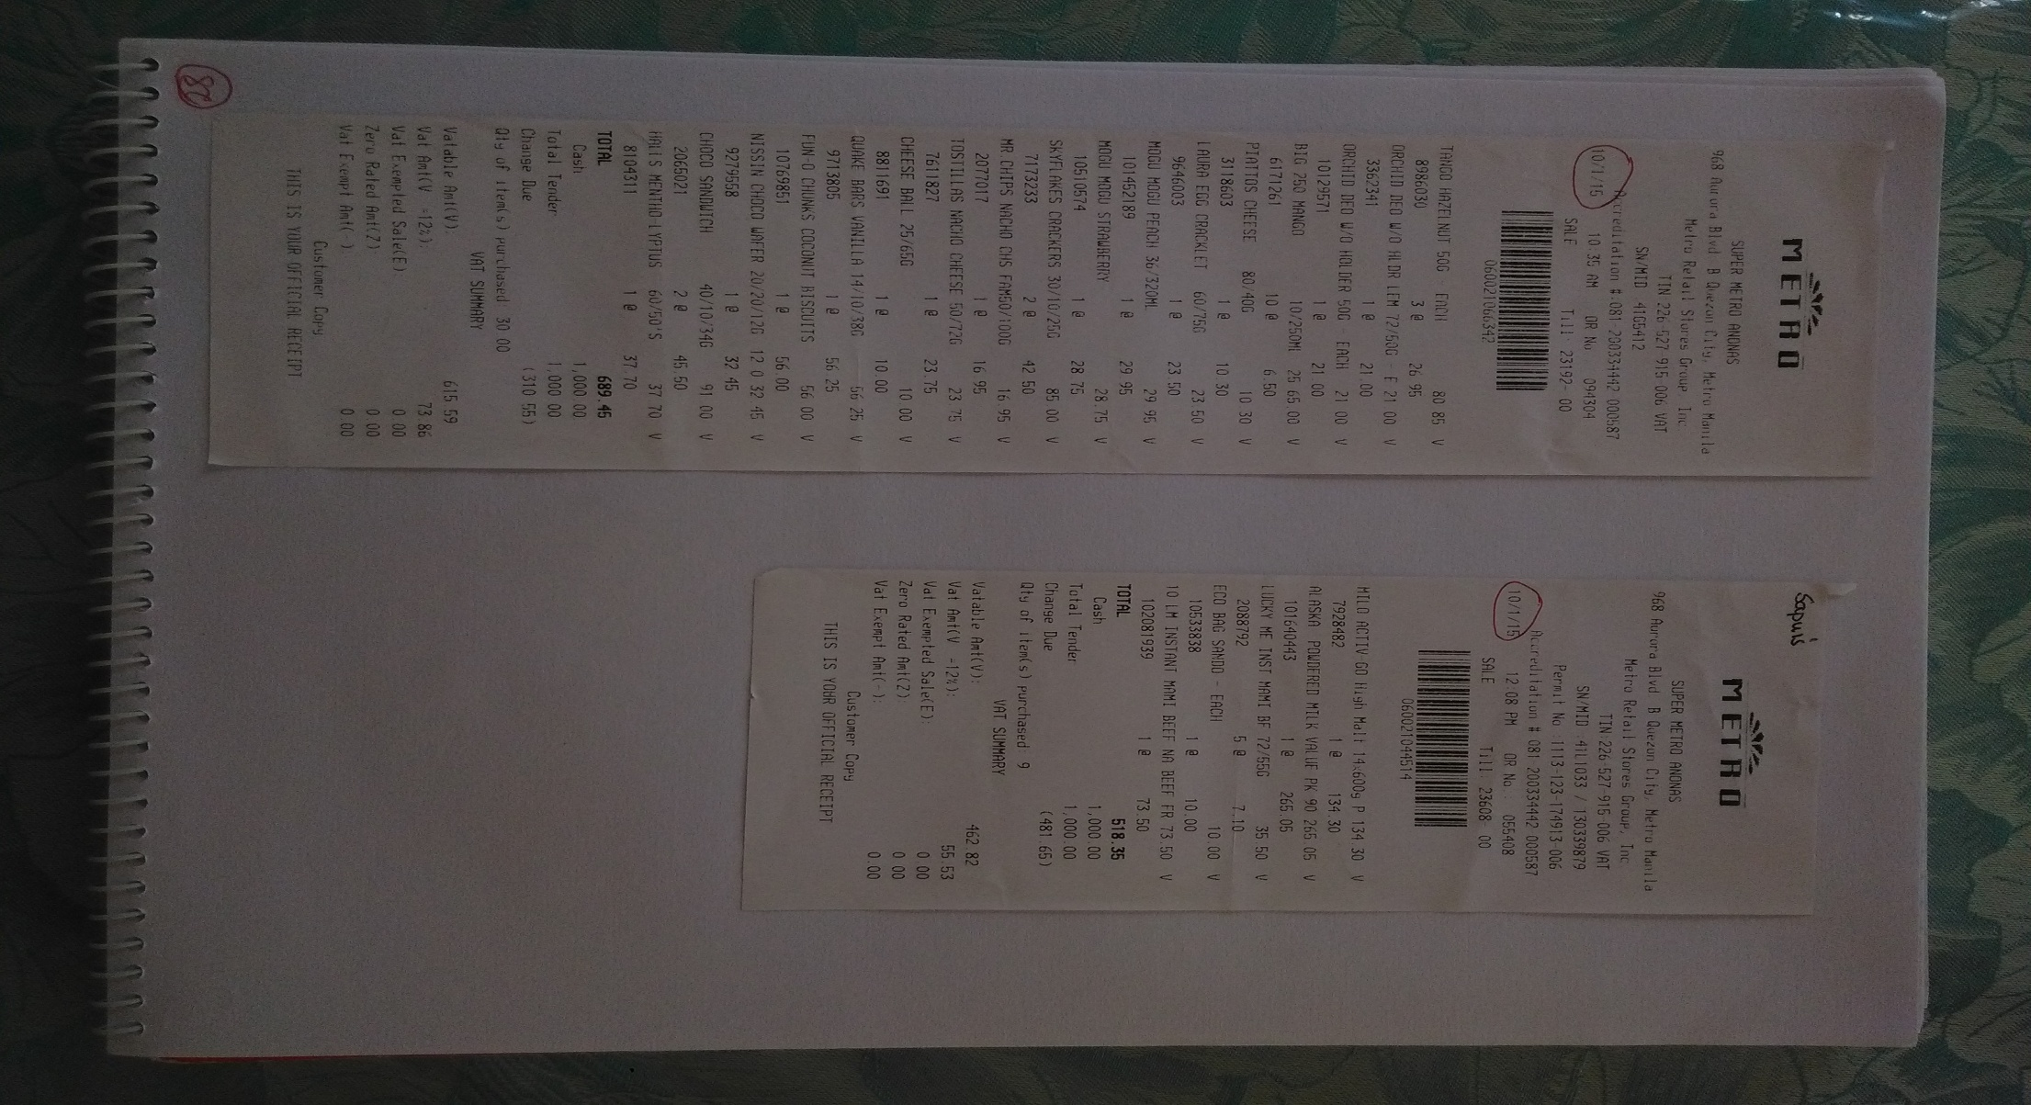
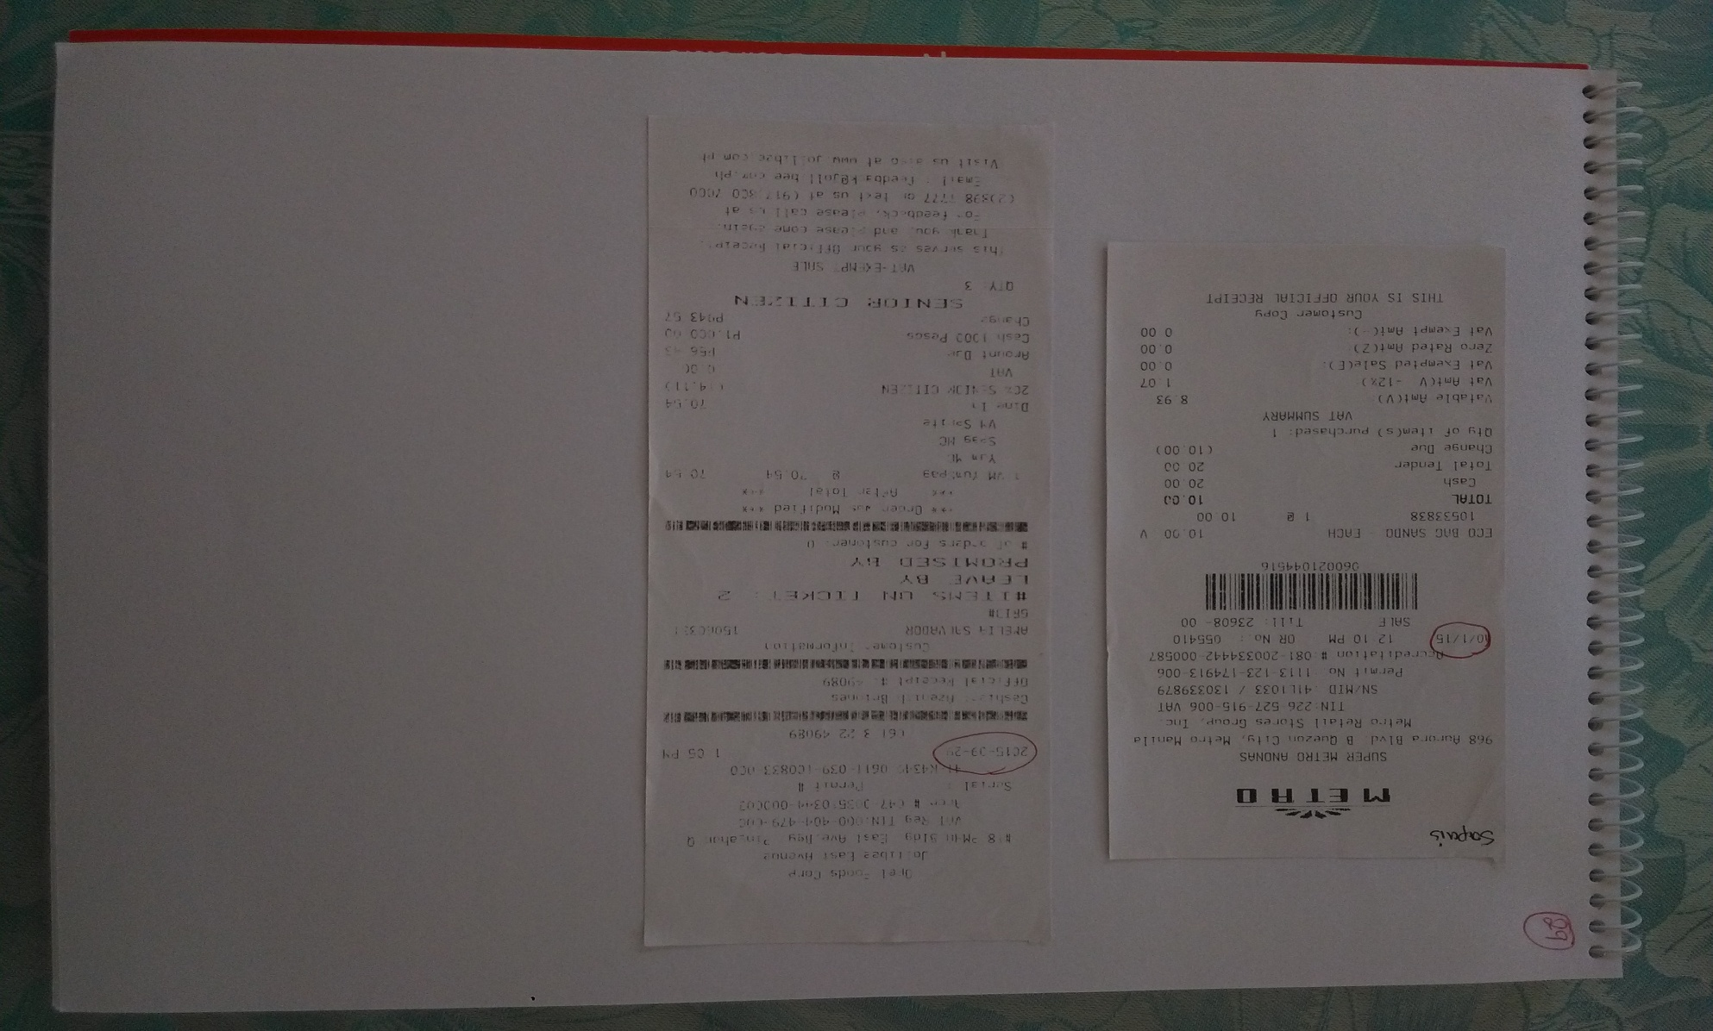

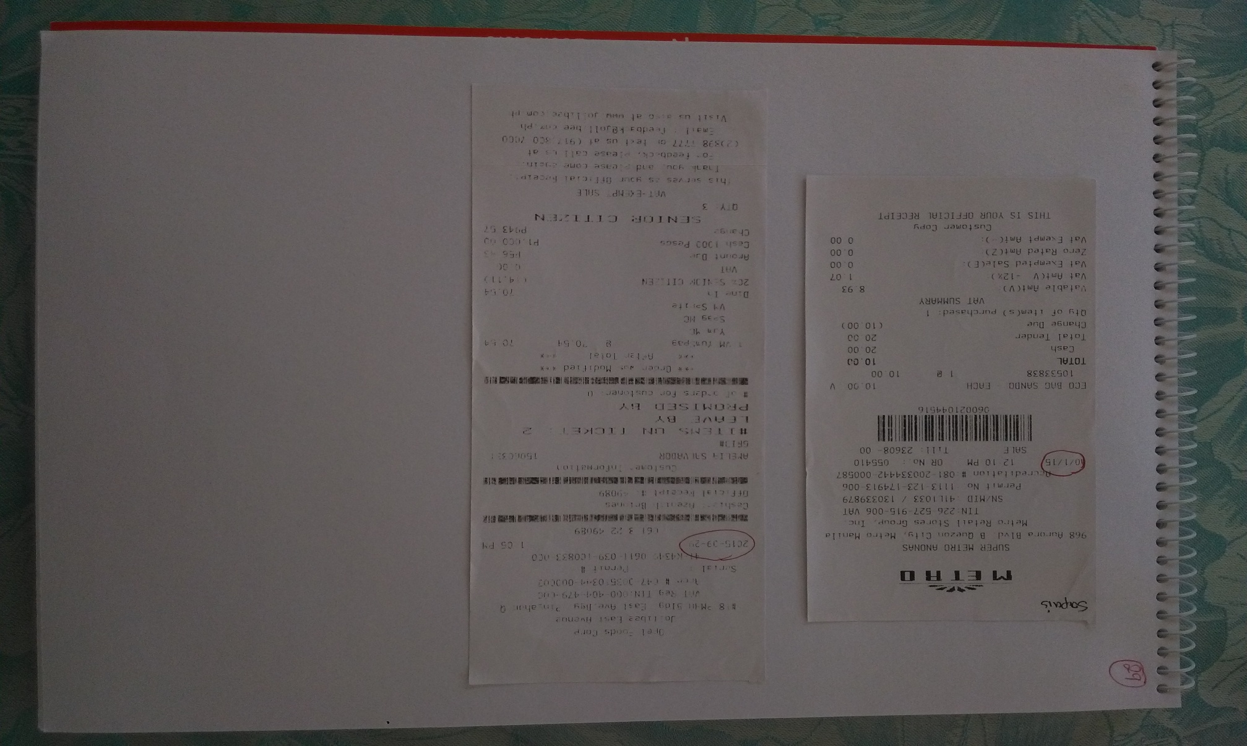

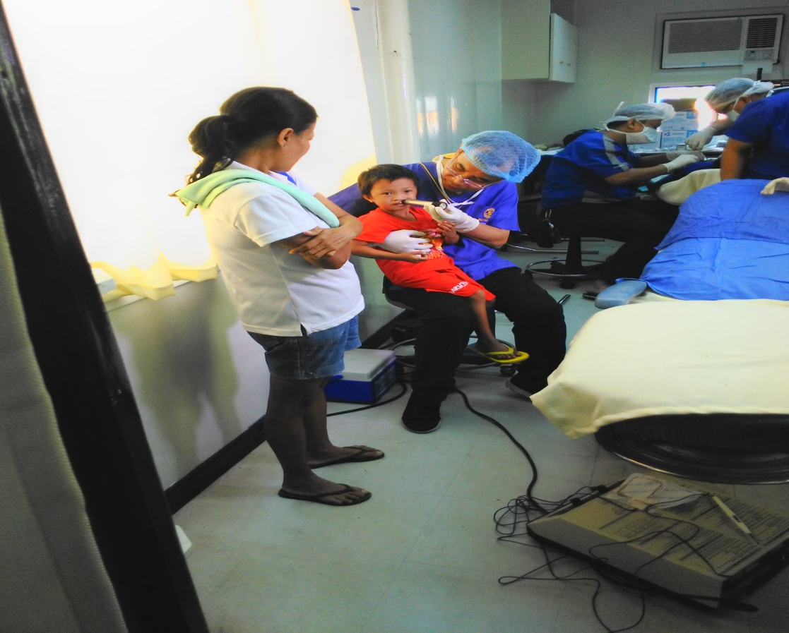

First check up

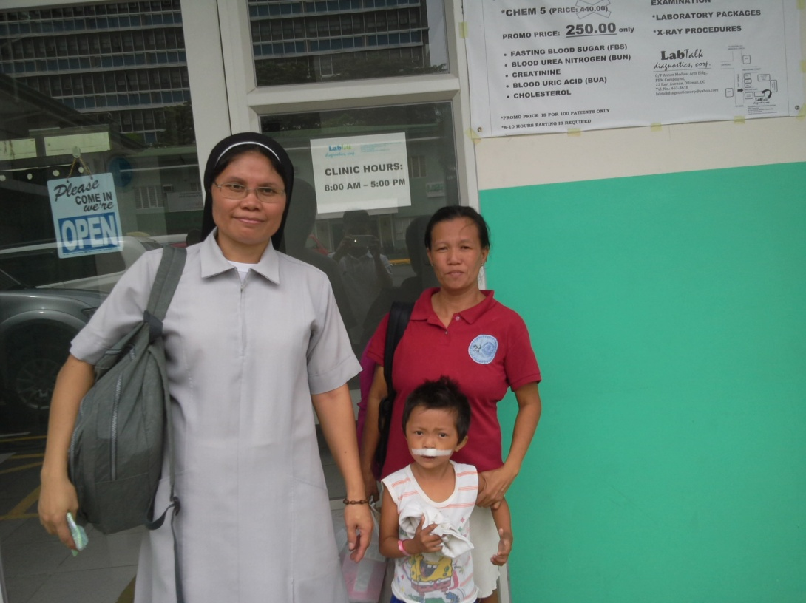

After operation
Going out from the hospital

Sapues Expenses
September
transpo | 296
drinks | 50
food | 417
food | 56.43
c2 | 36
bread | 5
transpo | 391
transpo | 80
October
transpo | 207
eco bag | 10
groceries | 518
groceries | 689
transpo | 206
transpo | 163
Total | 3124.43

