January 5, 2016
Dearest Sabrina,
Peace and Goodwill!
I am Sr. Carlota the person responsible for the follow up of Reynold Sapuez. Sorry for the later update.
Thank you for your generosity and continuous support of our mission here in the Philippines I already received the money you sent 91,800 pesos.
Reynold’s resent update, he is still under medication of tuberculosis, and last Dec 22, 2015 we consulted the doctor because of his continuous fever, but doctor’s recommendation not to stop the medication and to give him more nutritious food. No operation will be done in this January, possible on February but still the doctors need to check if the Child is ready for operation. Reynold is under weight, with the money that you gave we are buying groceries for him particularly milk and talk also to the parents about health care and proper diet so this child can recover. About groceries we gave last month and this January 4, 2015.
The parents are grateful of all the support that you are giving.
The family; we visited them last Dec. 15, 2015 in their house and we were able to meet them except the father because he is out working. I attach here also the pictures. The mother is without work only the father as an irregular construction worker and paid weekly, so even them their regular food they find it hard to sustain, thanks that you are there who help Reynold to boost his body so he can be operated.
The mother sends you also a letter of thanks giving and a Christmas greetings I also attach it here.

Grateful of your heart, that is so caring and loving for all the people, and trust in the congregation.
And even I’m late; we are still in Christmas season.
Merry Christmas and a grace-filled New Year!
Happy Epiphany!
With prayer,
Sr. Carlota
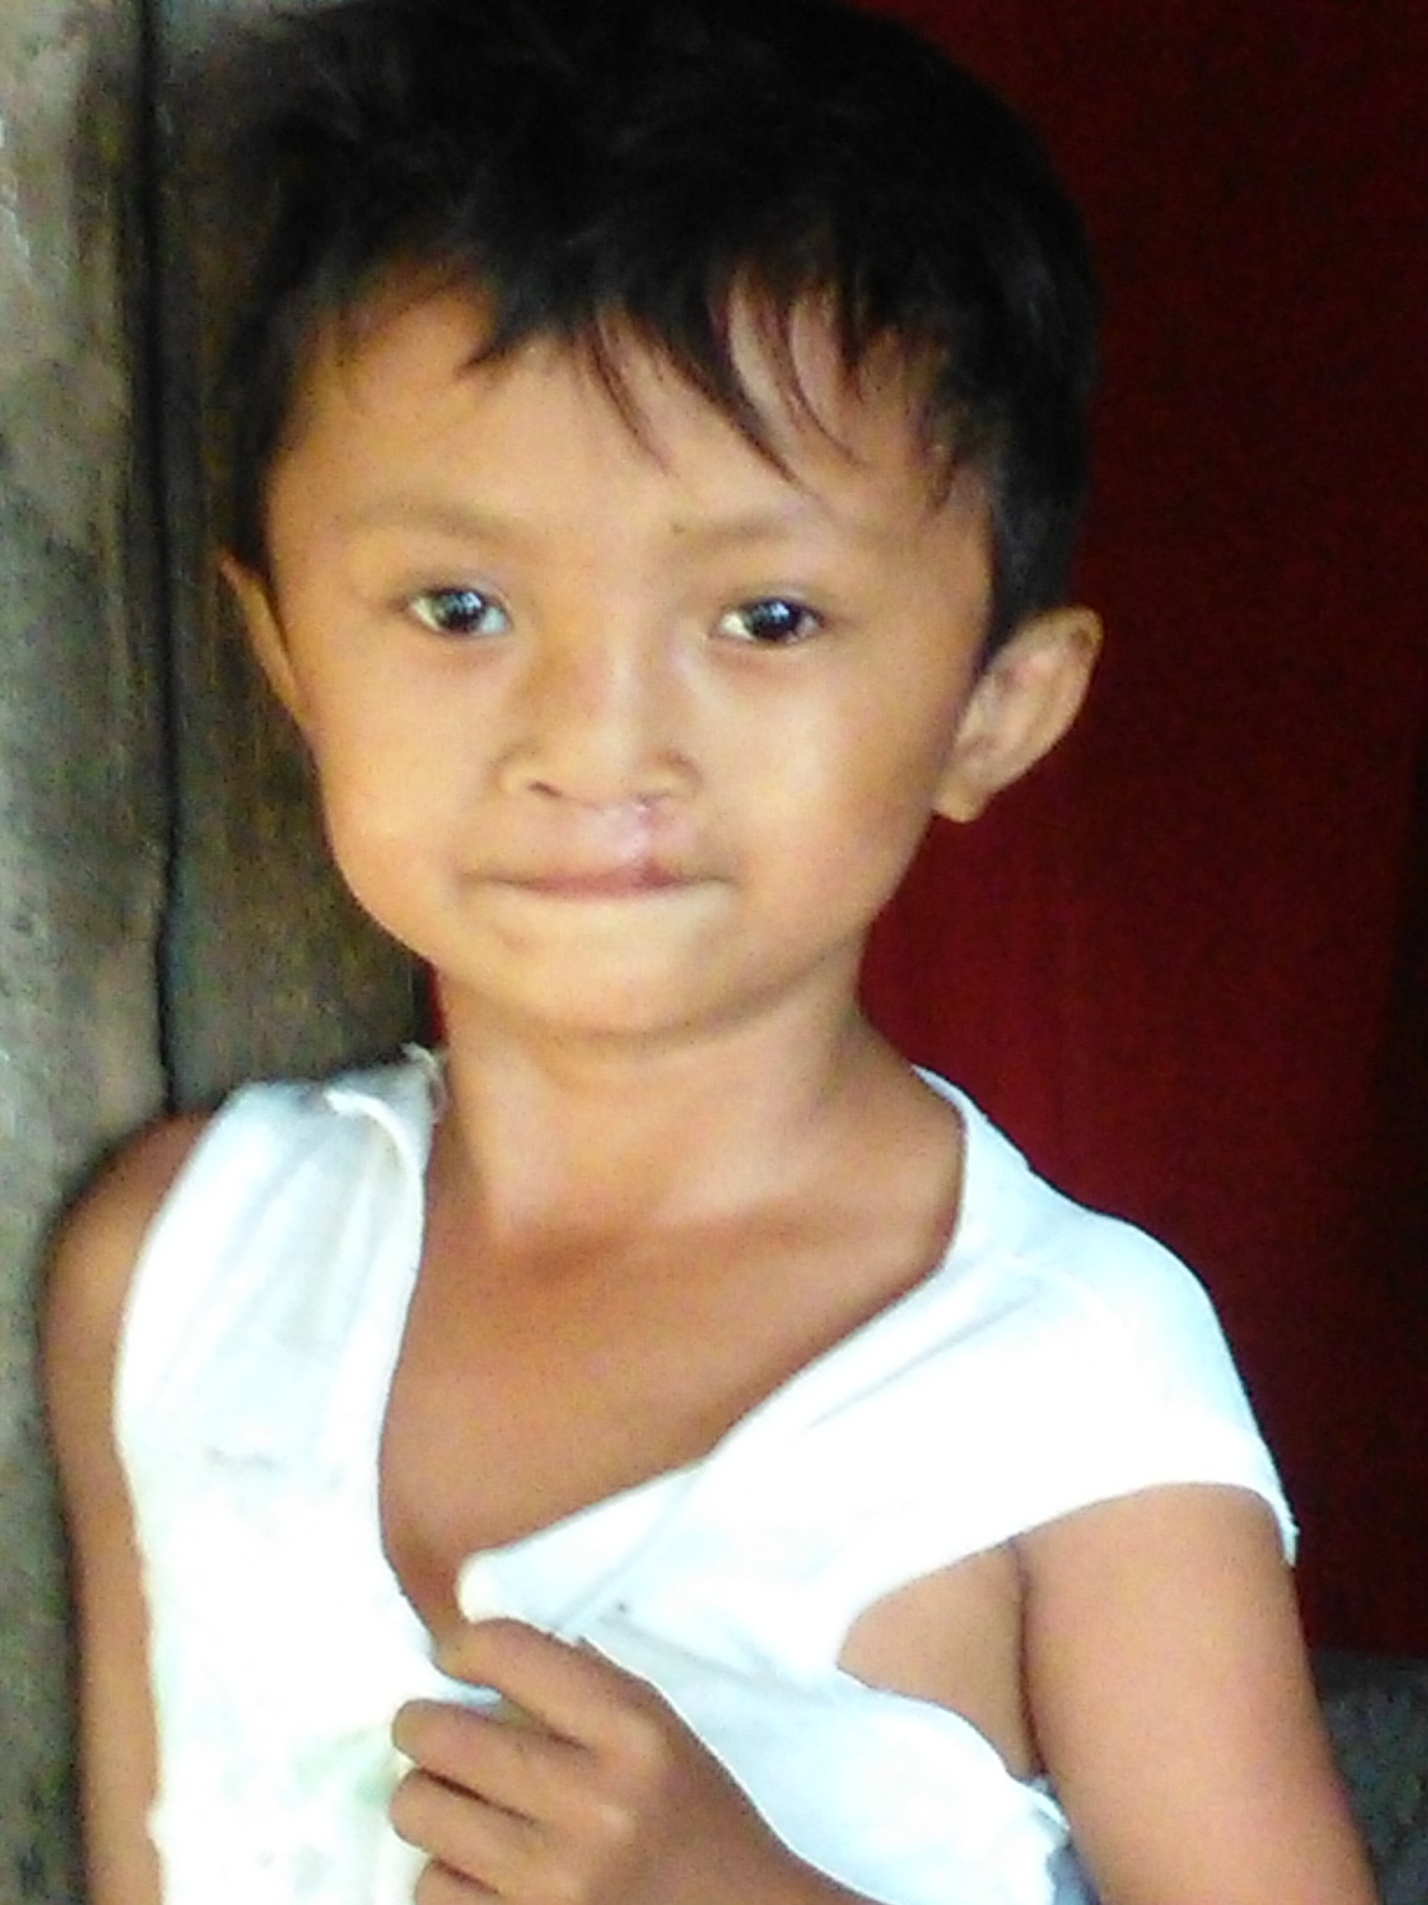
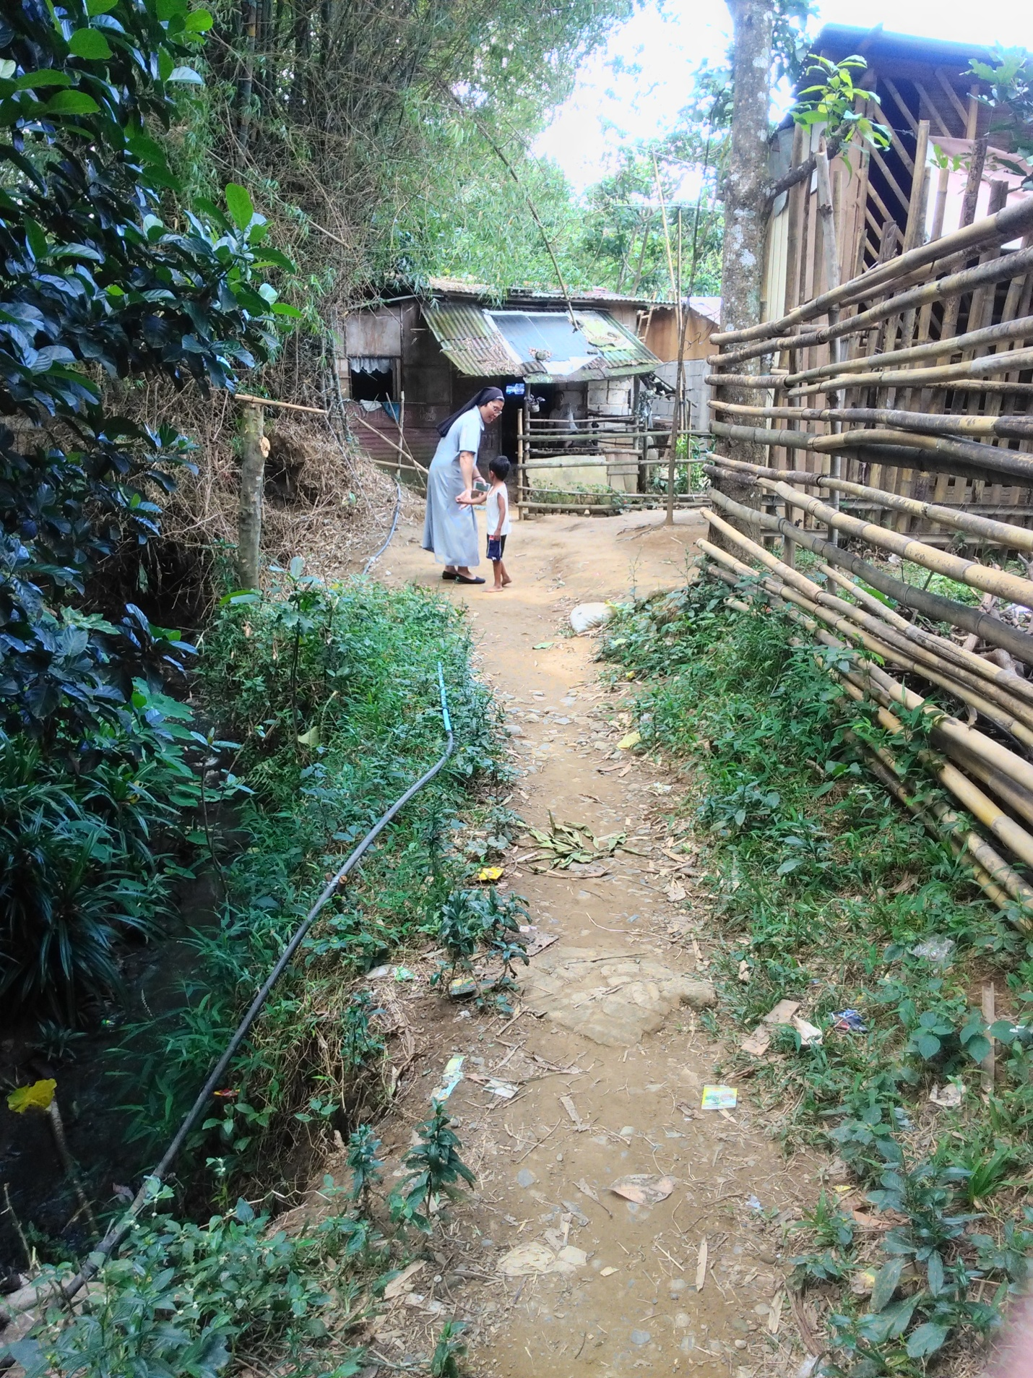
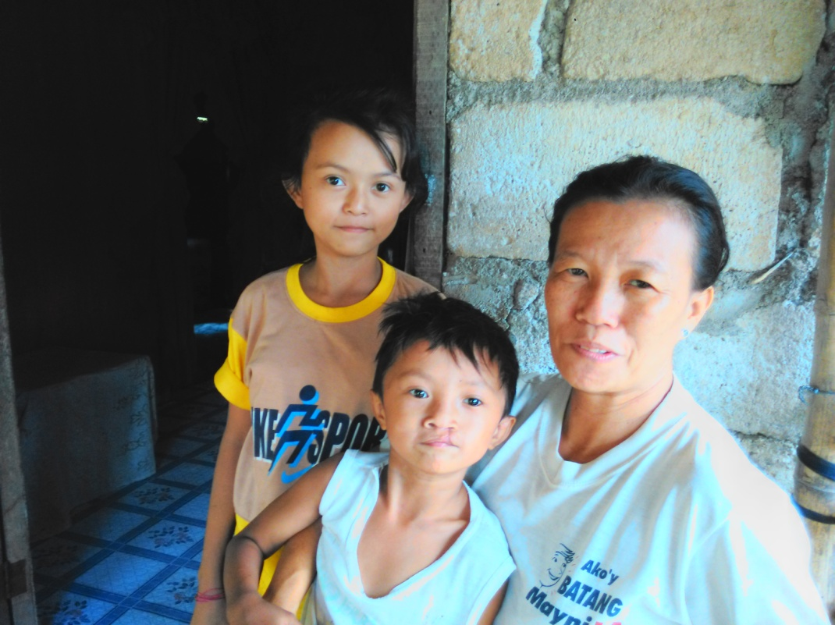

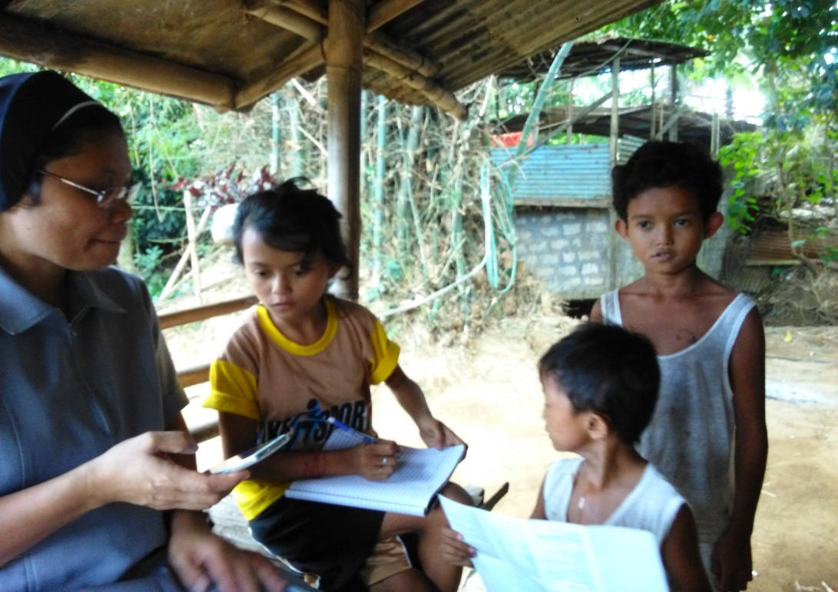

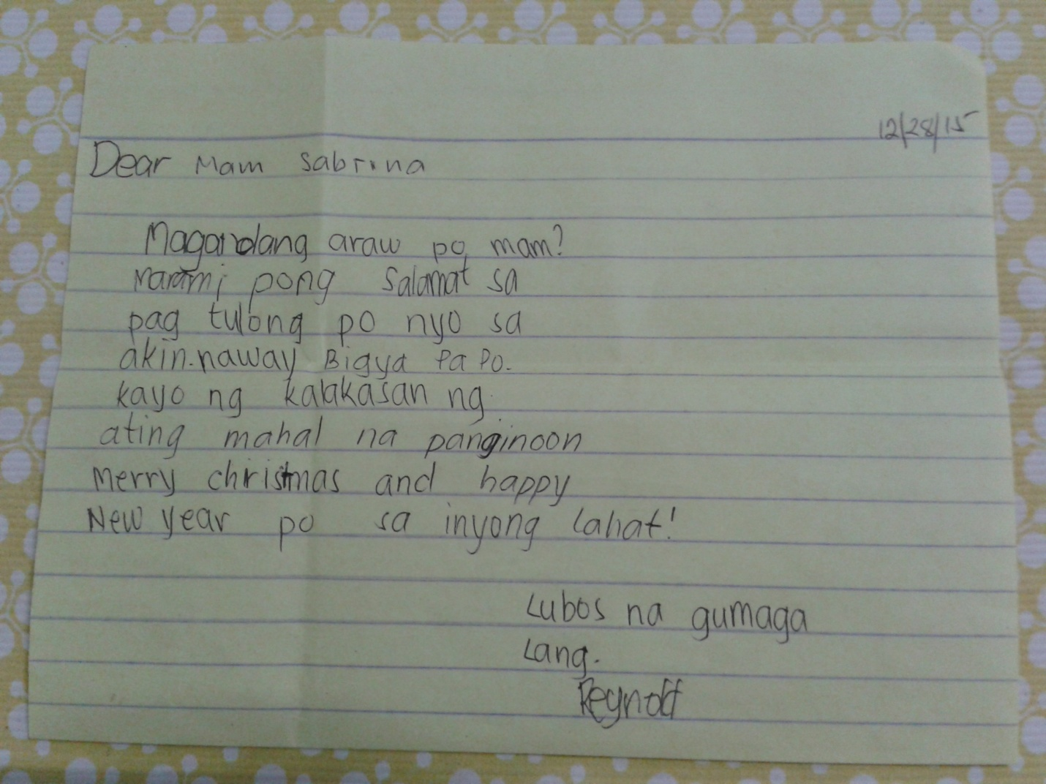
This is the letter that the mother sends for you, signed by Reynold but the child still doesn’t know how to write and only in this coming school year June 2016 he will inter in the school.
I just took picture of the letter.

